**Linux User Administration**

The user home directory by default is created under "**/home**" directory with the user name. e.g. User sun has home directory "**/home/sun**", the mail account is created under "**/var/spool/mail/**".  
  
Each user and group in the system is identified by a unique no called as ID.  
  
**There are two types of user:**  
  
1) **System users**  
2) **Normal users**  
  
The system users have ID values from 0 to 499  & the normal users can have ID values from 500 to 60,000.  
  
The users and groups are maintained by the four databases files. These are:  
  
**1) /etc/passwd**: This databases file maintains the user information like UID, GID, User name etc.  
**2) /etc/shadow**: This file maintains user password related information like uname, encrypted pwd, etc. The pwd's are encrypted in the pwd binary file. To encrypt the passwords, MD5sum, DES algorithms are used.  
**3) /etc/group**: It maintains group related information like group name, GID, etc.  
**4) /etc/gshadow**: It maintains the group password related information.   
  
**User administration :**  
  
For **user administration** five commands are used.  
  
**1) useradd** : This command is used to create a new user with default values.  
$**useradd <options> <user-name>**  
  
where the options can be,  
  
-U = User id  
-g = group ID (primary)  
-G = group ID (secondary)  
-c = comment  
-d = directory   
-s  = shell   
-f  = inactive days  
-e = expire date (YYYY MM DD)  
-m = change default home directory used with –d option

-M = user without home directory

-k or –skel = manually specifying skell directory

**2) usermod** : This command is used to modify the user accounts. Only the administrator can use this command. It's syntax is,  
$**usermod <options> <user-name>**

1. -c = We can add comment field for the useraccount.
2. -d = To modify the directory for any existing user account.
3. -e = Using this option we can make the account expiry in specific period.
4. -g = Change the primary group for a User.
5. -G = To add a supplementary groups.
6. -a = To add anyone of the group to a secondary group.
7. -l = To change the login name from tecmint to tecmint_admin.
8. -L = To lock the user account. This will lock the password so we can’t use the account.
9. -m = moving the contents of the home directory from existing home dir to new dir.
10. -p = To Use un-encrypted password for the new password. (NOT Secured).
11. -s = Create a Specified shell for new accounts.
12. -u = Used to Assigned UID for the user account between 0 to 999.
13. -U = To unlock the user accounts. This will remove the password lock and allow us to use the user account.

    
  
**3) passwd**:  This command is used to generate the passwords for users account.  
$**passwd < user-name>**

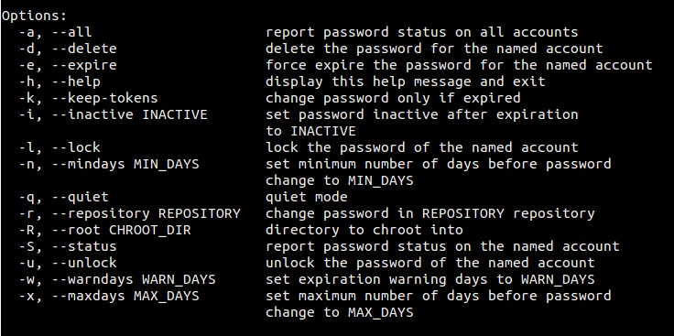  
  
**4) userdel** : This command is used to delete a user account.  
$**userdel <user-name>**  
  
**5) change** : This command is used to change the password expiry information.   
$**chage <user name>**

|  |  |
| --- | --- |
| **Option** | **Description** |
| **-m days** | **Specify the minimum number of days between which the user must change passwords. If the value is 0, the password does not expire.** |
| **-M days** | **Specify the maximum number of days for which the password is valid.** |
| **-d days** | **Specify the number of days since January 1, 1970 the password was changed.** |
| **-I days** | **Specify the number of inactive days after the password expiration before locking the account. If the value is 0, the account is not locked after the password expires.** |
| **-E date** | **Specify the date on which the account is locked, in the format YYYY-MM-DD. Instead of the date, the number of days since January 1, 1970 can also be used.** |
| **-W days** | **Specify the number of days before the password expiration date to warn the user.** |
|  | **Description** |
| useradd | Adds accounts to the system. |
| usermod | Modifies account attributes. |
| userdel | Deletes accounts from the system. |
| groupadd | Adds groups to the system. |
| groupmod | Modifies group attributes. |
| groupdel | Removes groups from the system. |

groupadd [options] group

**Options :**

**-g, –gid GID**  
The numerical value of the group’s ID. This value must be unique, unless the -o option is used. The value must be non-negative.  
**-h, –help**  
Display help message and exit.  
**-o, –non-unique**  
This option permits to add a group with a non-unique GID.  
**-p, –password PASSWORD**  
The encrypted password, as returned by crypt. The default is to disable the password.  
**-f, –force**  
This is the force flag. This will cause groupadd to exit with an error when the group about to be added already exists on the system. If that is the case, the group won’t be altered (or added again).  
This option also modifies the way -g option works. When you request a gid that it is not unique and you don’t specify the -o option too, the group creation will fall back to the standard behavior (adding a group as if neither -g or -o options were specified).  
**-K, –key KEY=VALUE**  
Overrides /etc/login.defs defaults (GID_MIN, GID_MAX and others). Multiple -K options can be specified. Example: -K GID_MIN=100 -K GID_MAX=499

The following configuration variables in /etc/login.defs change the behavior of this tool:

GID_MAX (number), GID_MIN (number)

Range of group IDs used for the creation of regular groups by useradd, groupadd, or newusers. The default value for GID_MIN (resp. GID_MAX) is 1000 (resp. 60000).

MAX_MEMBERS_PER_GROUP (number)

Maximum members per group entry. When the maximum is reached, a new group entry (line) is started in /etc/group (with the same name, same password, and same GID). The default value is 0, meaning that there are no limits in the number of members in a group. This feature (split group) permits to limit the length of lines in the group file. This is useful to make sure that lines for NIS groups are not larger than 1024 characters. If you need to enforce such limit, you can use 25.

## Create an User :

#useradd -d homedir -g groupname -m -s shell -u userid accountname

|  |  |
| --- | --- |
| **Option** | **Description** |
| -d homedir | Specifies home directory for the account. |
|  |  |
| -g groupname | Specifies a group account for this account. |
| -m | Creates the home directory if it doesn't exist. |
| -s shell | Specifies the default shell for this account. |
| -u userid | You can specify a user id for this account. |
| accountname | Actual account name to be created |

id tecmint

### Add a User without Home Directory

# useradd -M shilpi

### Add a User with Specific Home Directory, Default Shell and Custom Comment

# useradd -m -d /var/www/ravi -s /bin/bash -c "TecMint Owner" -U ravi

#### Usermod

#### -c = We can add comment field for the useraccount.

#### -d = To modify the directory for any existing user account.

-e = Using this option we can make the account expiry in specific period.

-g = Change the primary group for a User.

-G = To add a supplementary groups.

-a = To add anyone of the group to a secondary group.

-l = To change the login name from tecmint to tecmint_admin.

-L = To lock the user account. This will lock the password so we can’t use the account.

-m = moving the contents of the home directory from existing home dir to new dir.

-p = To Use un-encrypted password for the new password. (NOT Secured).

-s = Create a Specified shell for new accounts.

-u = Used to Assigned UID for the user account between 0 to 999.

-U = To unlock the user accounts. This will remove the password lock and allow us to use the user account

**Delete an Account :** userdel -r mcmohd20

## Create a Group

groupadd [-g gid [-o]] [-r] [-f] groupname

|  |  |
| --- | --- |
| **on** | **Description** |
| -g GID | The numerical value of the group's ID. |
| -o | This option permits to add group with non-unique GID |
| -r | This flag instructs groupadd to add a system account |
| -f | This option causes to just exit with success status if the specified group already exists. With -g, if specified GID already exists, other (unique) GID is chosen |
| groupname | Actual group name to be created. |

## Modify a Group

To modify a group, use the **groupmod** syntax −

$ groupmod -n new_modified_group_name old_group_name

To change the developers_2 group name to developer, type −

$ groupmod -n developer developer_2

Here is how you would change the financial GID to 545 −

$ groupmod -g 545 developer

## Delete a Group:

To delete an existing group, all you need are the groupdel command and the group name. To delete the financial group, the command is −

$ groupdel developer

This removes only the group, not any files associated with that group. The files are still accessible by their owners.

# Gpasswd :

### 1. Add user (tracy) to the group (hrd)

$ gpasswd -a tracy hrd

### 2. Add multiper users to the group (developer)

$ gpasswd -a pavan,john developer

### 3. Remove user (rakesh) from group (sqa)

$ gpasswd -d rakesh sqa

### 4. Remove multiple users from group (managers)

$ gpasswd -d shane,ron,ram managers

### 5. Set user (joy) and group administrator for (managers)

$ gpasswd -A joy managers

### 6. Set password for group

$ gpasswd managers

Changing the password for group managers

New Password:

Re-enter new password: